Coral Springs Basketball Club
2009 Scholarship

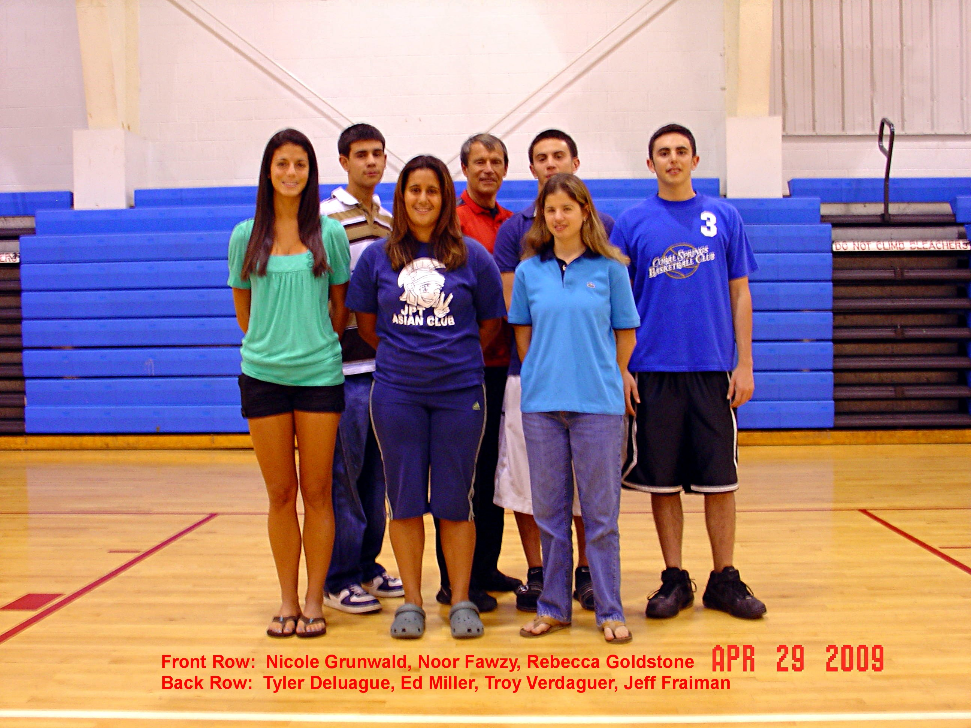

Jon Miller Memorial Scholarship Award

The Coral Springs Basketball Club is proud to announce the Jon Miller Memorial Scholarship Award program for club members who are in their senior of High School. To date, the Club has awarded over $100,000 in scholarships.

Scholarships up to $1,000 will be awarded to deserving club members and will be presented during High School graduation or award ceremonies.

